Practical No.06
Configure IOS Intrusion Prevention System (IPS) Using the CLI
a.Enable IOS IPS.
b.Modify an IPS signature.
Network

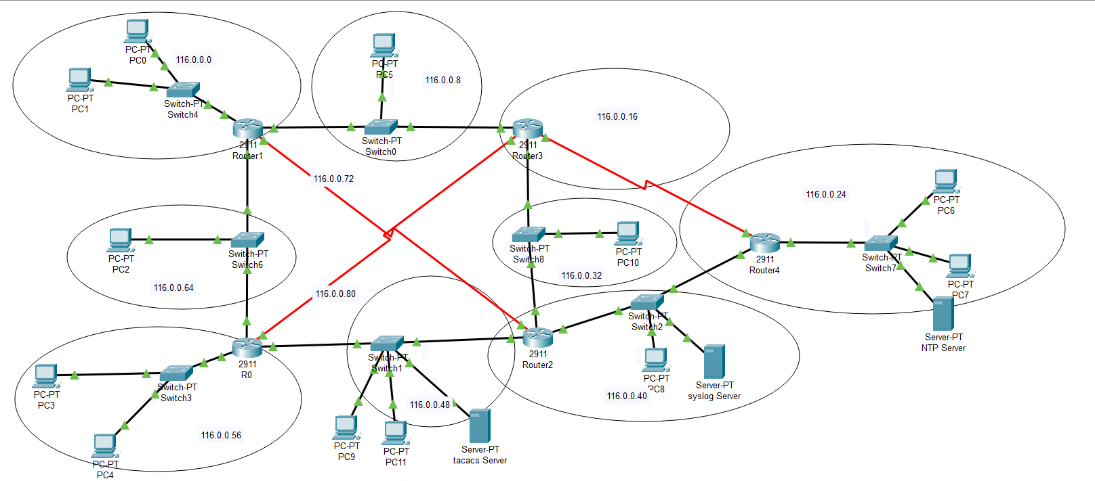
Commands to enable ios_ips on Router2 with syslog server
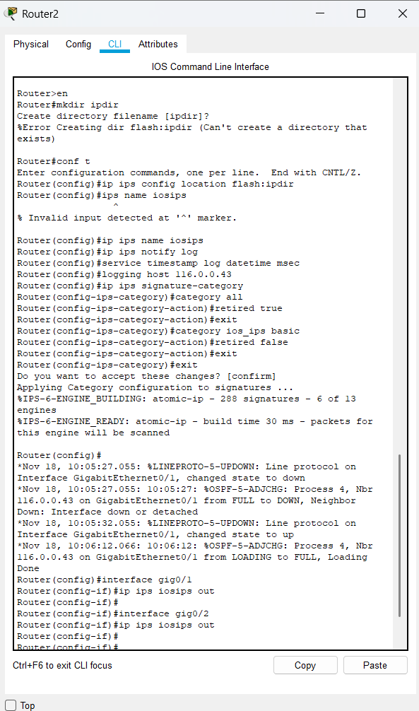
Below are the commands To modify the signatures
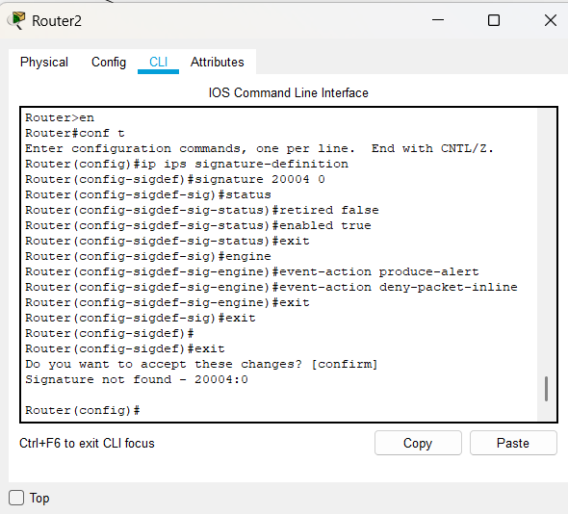

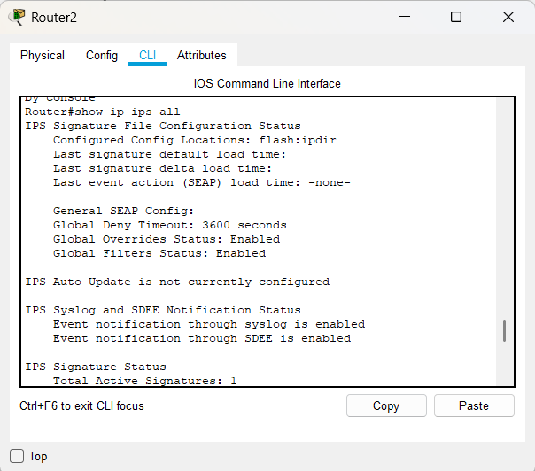
Before configuring ios_ips the devices were able to ping the devices from ios_ips enabled interface

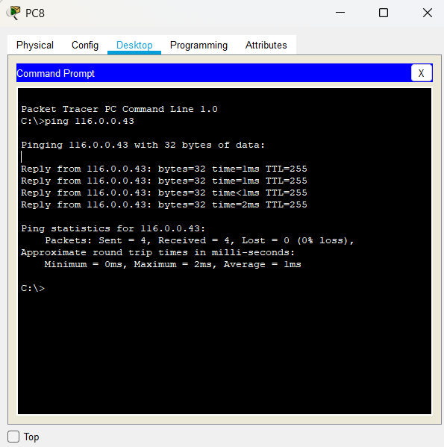
After configuring ios_ips outside devices are not able to ping the from ios_ips enabled interface
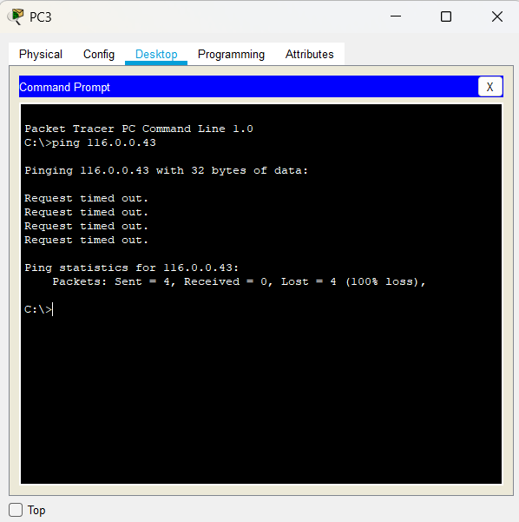
Logs:
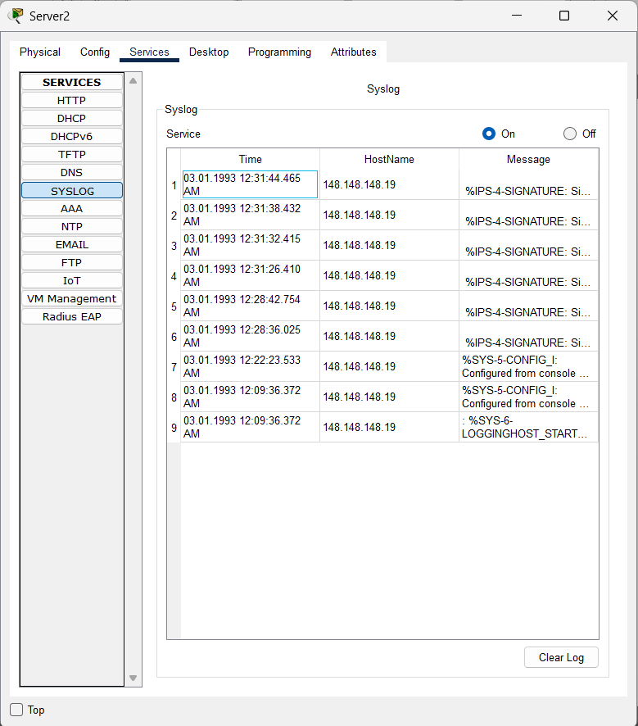
Ios_ips enabled network is able to ping the devices from the outside network

